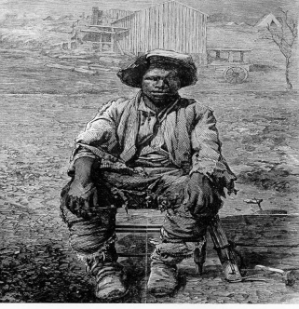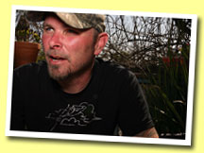

"Prosser's Gabriel" song by Tim Barry
Does anyone know the name Gabriel Prosser?
My conscience says he's the one that history missed
A blacksmith by trade up at Brookfield Plantation
A Henrico County slave born to owner Thomas
If you listen closely you'll hear the words perfect
The Caribbean uprising caught fire in this land
Up and down the James river Pamunkey and Appomattox
Tobacco soil gone bad afforded movement for the blacks
Nine years before down in Santo Domingo
Slaves refused to submit and took the right of all man
Virginia whites got nervous and armed more militias
As blacks inspired plotted and passed on their plans
Mr. Prosser's Gabriel was smart as he was strong
A head of keloid scars and a mind of knowing right and wrong
Voted general at 24 in the year of 1800
Haunted by the hymns wailing of his fellow slaves
Now does anyone know the name Gabriel Prosser?
My conscience says he's the one that history missed
A blacksmith by trade up at Brookfield Plantation
A Henrico County slave born to owner Thomas
It was on an August night outside of Richmond Virginia
Gabriel's men gathered as their owners they slept
Some would burn city streets to attract residents and masters
While others took the capital and freed convicts

Well, the whites they knew nothing, never seen what could hit them
Nothing like this could happen with their carefree black men
But think about freedom, now think about slavery
Blacks armed themselves with muskets and homemade bayonets
With a white flag on the capital all blacks they would rise
Whites spared would all lose an arm
You're a coward if you own men for profit and greed
You're the coward of all and for all you must bleed
Now does anyone know the name Gabriel Prosser?
My conscience says he's the one that history missed
A blacksmith by trade up at Brookfield Plantation
A Henrico County slave born to owner Thomas
Pharaoh and Tom ratted out Gabriel Prosser
Their owner was Mosby a neighbor of him
They say the sky's seen seas of rain and lightning
On the night of August 30th one could see nor stand
The militias let loose to hunt Gabriel Prosser
Who took to the swamps as they imprisoned his men
Flagged a boat whose captain was a Methodist preacher
But a traitor slave turned him in in the end
They hung Gabriel down at Broad and 15th street
Lord, he would not give a word up on his men
But he took that noose and he took it with honor
He's buried beneath parked cars now and pavement
There's no monument there's no stone here to see him
Just black asphalt flanked by high rise hospital chains
If I had it my way, we'd see memorials climbing
To a true and honest hero, Prosser's Gabriel
Now does anyone know the name Gabriel Prosser?
My conscience says he's the one that history missed
A blacksmith by trade up at Brookfield Plantation
A Henrico County slave born to owner Thomas

