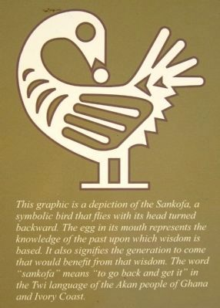
Thinking about the future
Instructions:
- Read these questions and discuss them with your group
- Check them off as you answer them together
- Add any new information to your graphic organizers
- You may also record additional ideas/responses on the back of this handout
Historian’s Name: _________________________________________

- Why did Gabriel lead the rebellion?
- What happened - before, during, and after his failed rebellion?
- What is the historical importance of this event?
- Why isn't his story more well known?
- Why did they pave over the African burial ground?
- Why is this historical site still important today?
- Why could it be important for future generations?
- What can we learn from this historical site and these historical events?
- What do you think about this historical site, now that you've done your research? What are your feelings on the matter?
- What should (or shouldn't) be done to protect it?

NOTES: record facts and ideas below:
What did you learn from watching the video on the African Burial Ground in New York City?

What did you learn from your assigned group reading for Step 5?

What new ideas might you have about preserving Richmond’s African Burial Ground?

