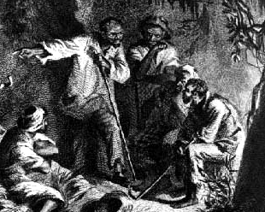 Name: _____________________________ Group: _______________________
Web Quest: VA Studies: Gabriel Prosser
Setting | Where and When?
Characters | Who were the key players?
Problem/Goal | What were the key players after?  What problem were they tackling?  What goal did they hope to achieve?
Events | Key events
Resolution/ Outcome | What resulted?  How was it resolved?  Did the key players solve their problem or attain their goal?  Why or why not?
Theme | Why is this event still important to us today?  What is its enduring significance?  What is there to be learned from it?

