Assignment: GABRIEL PROSSER
WEB QUEST GROUPS: Brainstorming Guide
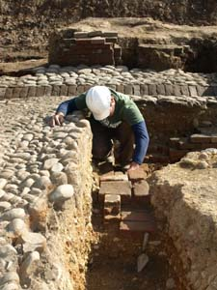

GROUP # 4: HISTORIANS/ HISTORIC PRESERVATIONISTS
You may brainstorm ideas with your group and jot them down below.

Who do you think a historian is? Who do you think a historic preservationist is? (Hint: what does “preservation” mean?)

What do historians and historic preservationists do? (hint: why is their work important?)

Once you’ve written a few ideas above, look up “historian” in the dictionary and historic preservation online (http://en.wikipedia.org/wiki/Historic_preservation) and define the two terms below:

Now share your findings with the class. Jot any new ideas down here:

Guidelines for your Web Quest assignment: Review as a class:

As a member of this group, you must:

- Conduct research together
- Communicate findings with each other
- Think about your group’s point of view relative to what you’ve learned through your research
- Present your opinions in a mock trial meeting
Individually, you must:

- Use this brainstorming guide to help you 1) get into character, 2) conduct research, and 3) develop an opinion.
- Carefully and thoughtfully research the web sites in the Web Quest
- Use organizers to jot down some notes about your opinions from the perspective of your role. (Hint: how might an average public citizen think or feel about this subject?)
- Prepare to be able to 1) write a letter expressing your opinion and 2) orally present your opinions in a mock town hall meeting.

Check these off to show that you understand:

- The introduction to the Web Quest.
- The goals of the Web Quest
- What work you will need to do in your group
- What work you are personally responsible for
- How you will be graded (see Evaluation tab on Web Quest).
- It’s always okay to ask questions. If you get stuck or you’re having problems, please feel free to come and talk with me.

Student signature: ___________________________________________

Date: ________________________________

Teacher comments: Date: ___________:

