Assignment: GABRIEL PROSSER
WEB QUEST GROUPS: Brainstorming Guide
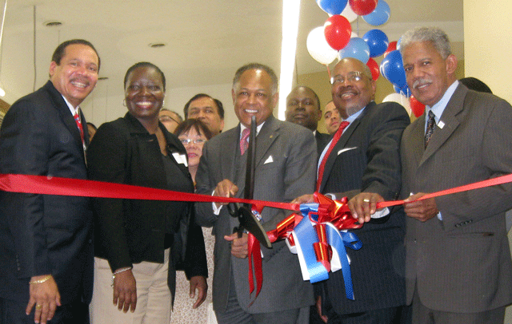

GROUP # 2: PUBLIC OFFICIALS FROM THE MAYOR’S OFFICE
You may brainstorm ideas with your group and jot them down below.

Who do you think public officials are?

What job(s) do public officials perform? (hint: what do they do for the city of Richmond?)

Once you’ve written a few ideas above, go to http://www.richmondgov.com/ and click on Government and Business – take a look at some of the functions public officials perform for the City of Richmond, and write your definition of what a public official is below:

Now share your findings with the class. Jot any new ideas down here:

Guidelines for your Web Quest assignment: Review as a class:

As a member of this group, you must:

- Conduct research together
- Communicate findings with each other
- Think about your group’s point of view relative to what you’ve learned through your research
- Present your opinions in a mock trial meeting
Individually, you must:

- Use this brainstorming guide to help you 1) get into character, 2) conduct research, and 3) develop an opinion.
- Carefully and thoughtfully research the web sites in the Web Quest
- Use organizers to jot down some notes about your opinions from the perspective of your role. (Hint: how might an average public citizen think or feel about this subject?)
- Prepare to be able to 1) write a letter expressing your opinion and 2) orally present your opinions in a mock town hall meeting.

Check these off to show that you understand:

- The introduction to the Web Quest.
- The goals of the Web Quest
- What work you will need to do in your group
- What work you are personally responsible for
- How you will be graded (see Evaluation tab on Web Quest).
- It’s always okay to ask questions. If you get stuck or you’re having problems, please feel free to come and talk with me.

Student signature: ___________________________________________

Date: ________________________________

Teacher comments: Date: ___________:

